Horizon-scanning tools can help align opportunities or build resilience into the business strategy. They can be useful to underpin the development of your strategy and plans.

You may have already heard of VUCA – an acronym that stands for volatile, uncertain, complex and ambiguous. BANI was introduced in 2020 and is set to replace VUCA. It stands for brittle, anxious, non-linear and incomprehensible.

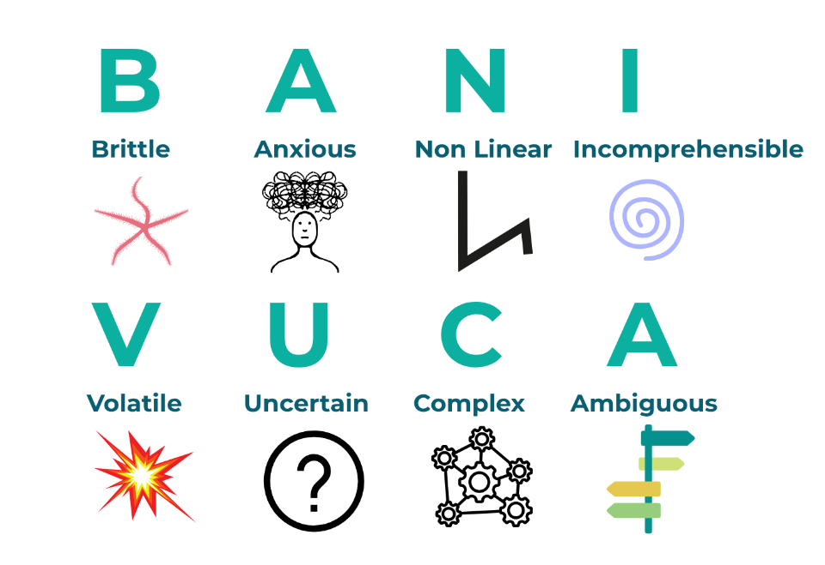

Both describe the challenges of operating in a fast-changing world. VUCA describes the volatility that’s now considered normal - BANI helps us consider the more chaotic and unpredictable impacts events can have on organisations. It calls out the non-linear nature of things leaders will need to navigate going forwards.

Events like the COVID-19 pandemic, climate, economic and world change mean organisations need to focus on how to cope in unpredictable situations and crises. BANI places emphasis on being prepared and staying ahead and alert.

Leaders can promote a culture of learning, innovation, risk-taking, and create an environment of trust that allows for a diverse range of voices and experiences to be heard to identify weaknesses and opportunities.

Here’s an optional video to bring the BANI framework to life:

[The BANI World, for IRSM 2022](https://www.youtube.com/watch?v=stBdyNBwfpU)